MCQ Assignment 2 level _intermidiate to hard (Marks 50 →2 marks each)

1. In the worksheet below, what do the symbols in rows 4, 6, 7, and 11 indicate?

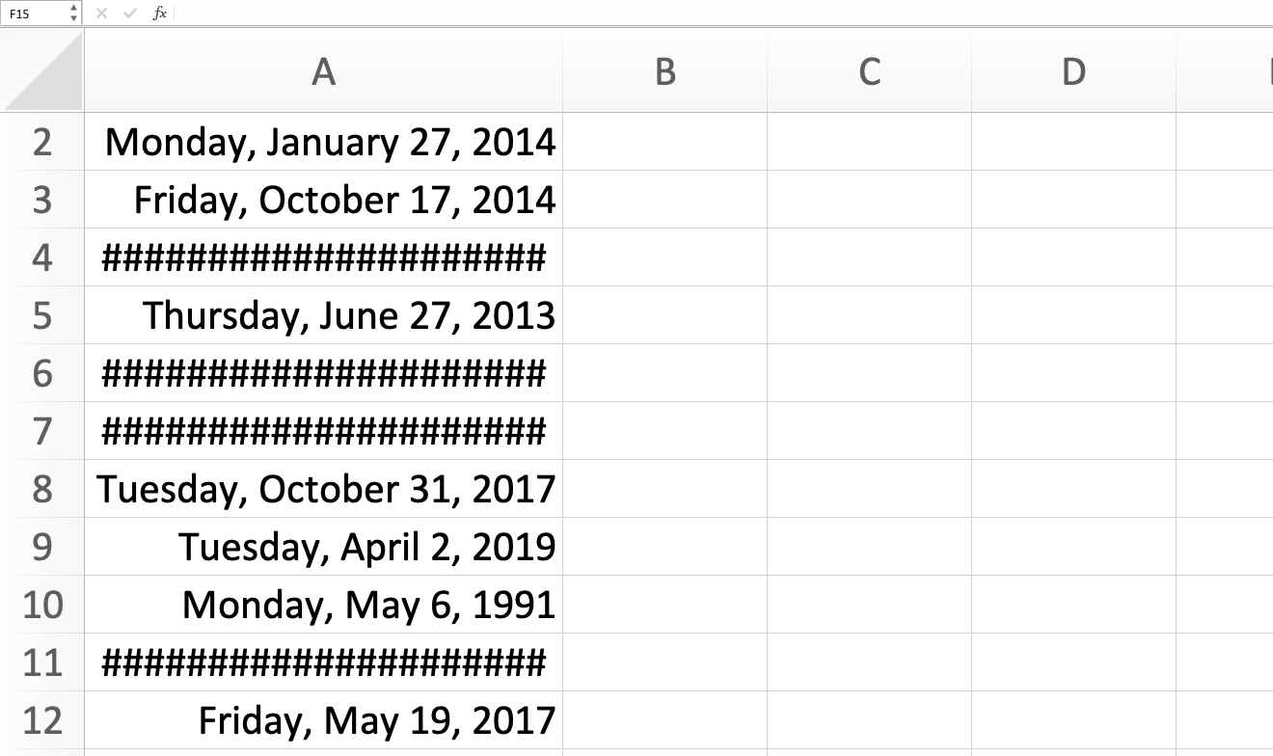

1. The dates are erroneous, such as October 39, 2015.
2. The columns aren't wide enough to show the full date.
3. The time are incorrectly formatted as dates.
4. The text is incorrectly formatted as dates.

2. What does the VLOOKUP function do in Excel?

a) Looks up a value in the leftmost column of a table and returns a value in the same row from a specified column

b) Looks up a value in the top row of a table and returns a value in the same column from a specified row

c) Searches for a value in a range and returns the position of that value

d) None of the above

3. Which Excel feature allows you to visualize data trends over time?

a) PivotTables

b) Conditional Formatting

c) Sparklines

d) Data Validation

4. In Excel, what function would you use to count the number of cells that contain numbers within a specified range?

a) COUNTA

b) COUNTBLANK

c) COUNTIF

d) SUM

5. You have a worksheet in Excel that will print as 10 pages. How can you ensure that the header row is printed at the top of each page?

1. Use Print Titles on the Page Layout tab.
2. Use Page Setup from the Backstage View.
3. Use Freeze Panes on the View tab.
4. Format your data as a table; the header prints automatically.

6.  **What type of chart is this?**

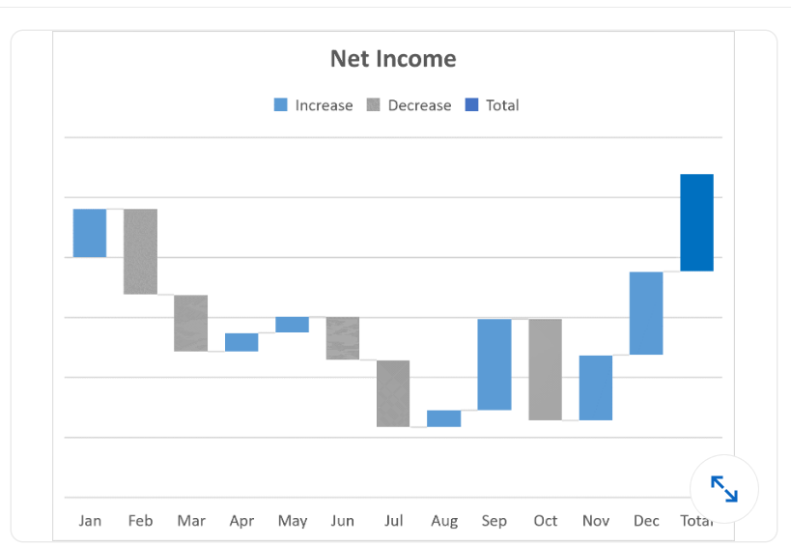

1. histogram
2. waterfall
3. Bar chart
4. box and whisker

7. Which Excel function would you use to calculate the future value of an investment based on constant, periodic payments and a constant interest rate?

a) PMT

b) FV

c) PV

d) NPER

8. What does the formula =SUM(A1:A10) do in Excel?

a) Adds the values in cells A1 through A10

b) Subtracts the values in cells A1 through A10

c) Multiplies the values in cells A1 through A10

d) Divides the values in cells A1 through A10

9. In Excel, what is the keyboard shortcut to autofill a series?

a) Ctrl + F

b) Ctrl + A

c) Ctrl + E

d) Ctrl + R

10. Which Excel feature would you use to prevent users from entering invalid data into a cell?

a) Data Validation

b) Conditional Formatting

c) Sparklines

d) Goal Seek

11. What does the COUNTIF function do in Excel?

a) Counts the number of cells that meet a certain condition

b) Adds up all the numbers in a range of cells

c) Returns the average of a range of cells

d) Finds the highest value in a range of cells

12. Which function is commonly used to combine data from multiple cells into one in Excel?

a) CONCATENATE

b) TRANSPOSE

c) SUBSTITUTE

d) INDEX

13. Which Excel function would you use to look up a value in a table vertically and return a corresponding value from the same row?

a) VLOOKUP

b) HLOOKUP

c) INDEX

d) MATCH

14. What is the primary purpose of a PivotTable in Excel?

a) To calculate the sum of a range of values

b) To visualize data trends over time

c) To filter and summarize large amounts of data

d) To create interactive charts

15. Which value is returned when you enter this function into cell G2? =IF(SUM(F2:F6)>12,"Too Many Tardy Days","No Tardiness Issue")

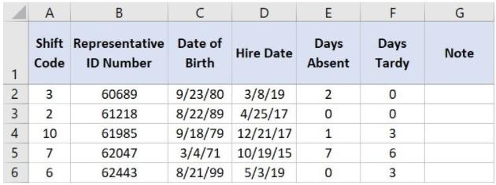

1. Too Many Tardy Days
2. #NUM!
3. No Tardiness Issue
4. #REF!

16. Which Excel tool allows you to filter PivotTable data dynamically based on specific criteria?

a) Slicer Tool

b) Filter Tool

c) Sort Tool

d) Subtotal Tool

17. Which function can be used to combine the functionality of VLOOKUP and HLOOKUP in Excel?

a) INDEX

b) MATCH

c) LOOKUP

d) TRANSPOSE

18. Which Excel feature allows you to create advanced calculations and data models using large datasets?

a) Power Pivot

b) Power Query

c) Power BI

d) Power View

19. What is the first step to activate the Excel Power Pivot Add-In?

a) Go to the Insert tab and click on PivotTable

b) Go to the Data tab and click on Get Data

c) Go to the File tab, select Options, and then click on Add-Ins

d) Go to the View tab and click on Macros

20. What is the primary purpose of creating data models with Power Pivot in Excel?

a) To create dynamic charts and graphs

b) To perform complex calculations and analysis

c) To import data from external sources

d) To create macros and automate tasks

21. You want to add a column to the PivotTable below that shows a 5% bonus for each sales rep. That data does not exists in the original data table. How can you do this without adding more data to the table?

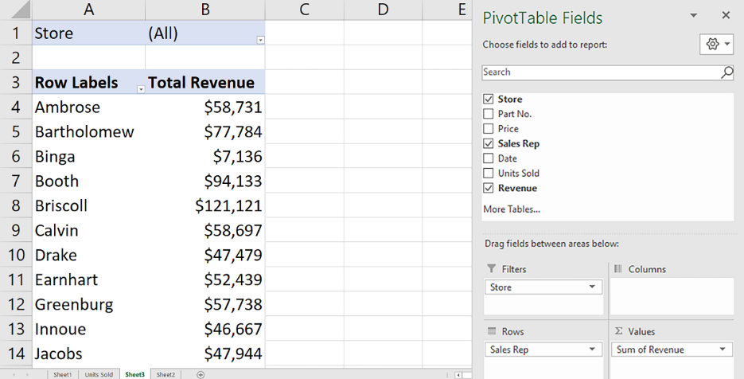

1. Add a new PivotTable field.
2. Add a calculated item
3. Add a new Summarize Value By field.
4. Add a calculated field.

22. Which function, when entered into cell G7, allows you to determine the sum total of annual sales for market regions 18 and greater?

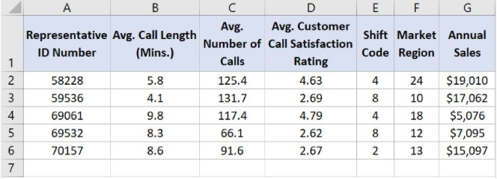

* a) =SUMIF(G2:G6,">17",F2:F6)
* b) =SUM(G2:G6,">=18,F2:F6)
* c) =SUMIF(F2:F6,">=18",G2:G6)
* d) =SUM(F2:F6,"18+",G2:G6)

23. Which VLOOKUP function, when entered into cell L2 and then dragged to cell L5, returns the average number of calls for the representative IDs listed in column J?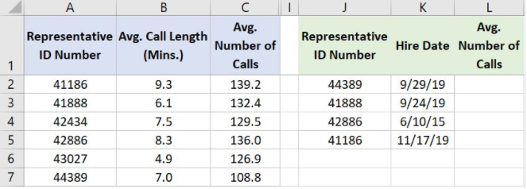

* a. =VLOOKUP(A2,J2:L5,1,FALSE)
* b. =VLOOKUP(J2,A$2:C$7,1,FALSE)
* c. =VLOOKUP(J2,A$2:C$7,3,FALSE)
* d. =VLOOKUP(J2,A2:C7,3,FALSE)

#### 24. How would you connect the slicer to both PivotTables?

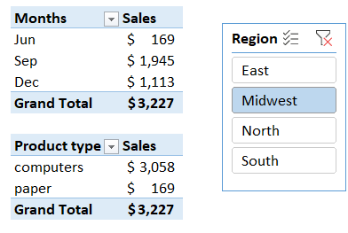

1. You cannot use one slicer for two PivotTables.
2. Right-click the slicer and select Slicer Settings.
3. Merge the two PivotTables, right-click the merged PivotTable, and select Combine Slicer.
4. Right-click the slicer and select Report Connections, or click Report Connections on the Slicer tab.

25. What feature can you use to populate B2:B7 with the number from each sectence in A2:A7?

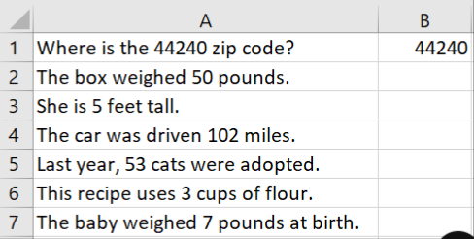

1. No Excel feature can accomplish this; this is possible only using formulas.
2. Flash Fill
3. Merge cells
4. Text to columns